# 实验四：SQLite和SQLiteDatabase应用

## 一、实验目的

1、本次实验的目的是让大家熟悉Android中对数据库进行操作的相关的接口、类等。SQLiteDatabase这个是在android中数据库操作使用最频繁的一个类。通过它可以实现数据库的创建或打开、创建表、插入数据、删除数据、查询数据、修改数据等操作。

2、实现添加用户名，爱好小例程。

## 二、实验要求

1、完成Android开发平台的搭建及相关配置

2、创建项目并熟悉文件目录结构

3、实现例程添加用户名，爱好实验步骤

**三、实验步骤**

在开始界面输入用户名和爱好，然后添加到数据库中，在主界面中显示出来。当长按列表项时会弹出删除选项，进行删除操作。

### 1、创建项目

新建一个Android工程命名为Database。

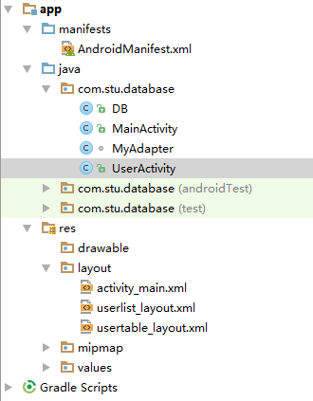

### 2、界面

开始界面

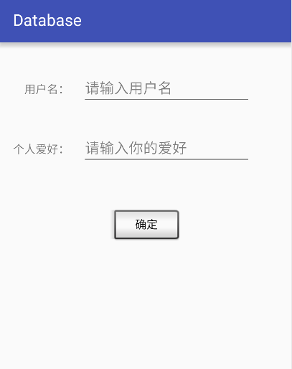

其对应的xml布局文件

*<?*xml version="1.0" encoding="utf-8"*?>*<RelativeLayout xmlns:android="http://schemas.android.com/apk/res/android"  
 xmlns:tools="http://schemas.android.com/tools"  
 android:id="@+id/activity_main"  
 android:layout_width="match_parent"  
 android:layout_height="match_parent"  
 android:paddingBottom="@dimen/activity_vertical_margin"  
 android:paddingLeft="@dimen/activity_horizontal_margin"  
 android:paddingRight="@dimen/activity_horizontal_margin"  
 android:paddingTop="@dimen/activity_vertical_margin"  
 tools:context="com.stu.database.MainActivity">  
  
 <TextView  
 android:text="个人爱好："  
 android:layout_width="wrap_content"  
 android:layout_height="wrap_content"  
 android:layout_below="@+id/tvUserName"  
 android:layout_marginTop="55dp"  
 android:id="@+id/tvUserHobby" />  
  
 <TextView  
 android:text="用户名："  
 android:layout_width="wrap_content"  
 android:layout_height="wrap_content"  
 android:layout_marginTop="32dp"  
 android:id="@+id/tvUserName"  
 android:layout_alignParentTop="true"  
 android:layout_alignRight="@+id/tvUserHobby"  
 android:layout_alignEnd="@+id/tvUserHobby" />  
  
 <EditText  
 android:layout_width="wrap_content"  
 android:layout_height="wrap_content"  
 android:inputType="text"  
 android:ems="10"  
 android:id="@+id/etUserName"  
 android:hint="请输入用户名"  
 android:layout_alignBaseline="@+id/tvUserName"  
 android:layout_alignBottom="@+id/tvUserName"  
 android:layout_toRightOf="@+id/tvUserName"  
 android:layout_toEndOf="@+id/tvUserName"  
 android:layout_marginLeft="15dp"  
 android:layout_marginStart="15dp" />  
  
 <EditText  
 android:layout_width="wrap_content"  
 android:layout_height="wrap_content"  
 android:inputType="text"  
 android:ems="10"  
 android:id="@+id/etUserHobby"  
 android:hint="请输入你的爱好"  
 android:layout_alignBaseline="@+id/tvUserHobby"  
 android:layout_alignBottom="@+id/tvUserHobby"  
 android:layout_alignLeft="@+id/etUserName"  
 android:layout_alignStart="@+id/etUserName" />  
  
 <Button  
 android:text="确定"  
 android:layout_width="wrap_content"  
 android:layout_height="wrap_content"  
 android:layout_marginTop="62dp"  
 android:id="@+id/btnSure"  
 style="@android:style/Widget.Button.Inset"  
 android:layout_below="@+id/etUserHobby"  
 android:layout_centerHorizontal="true"  
 android:onClick="btnSure_Click"/>  
</RelativeLayout>

主界面

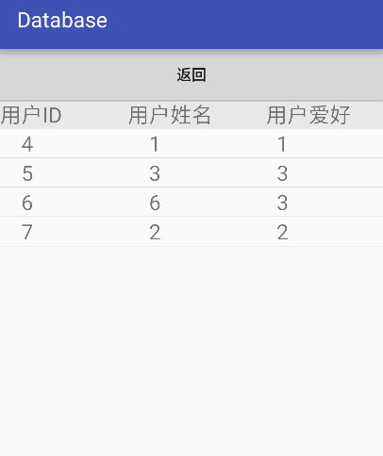

其对应的xml布局文件

*<?*xml version="1.0" encoding="utf-8"*?>*<LinearLayout xmlns:android="http://schemas.android.com/apk/res/android"  
 android:orientation="vertical"  
 android:layout_width="match_parent"  
 android:layout_height="match_parent">  
 <Button  
 android:text="返回"  
 android:layout_width="match_parent"  
 android:layout_height="wrap_content"  
 android:id="@+id/btnReturn"  
 android:onClick="btnReturn_Click"/>  
 <LinearLayout  
 android:layout_width="match_parent"  
 android:layout_height="wrap_content">  
  
 <TextView  
 android:layout_width="120dp"  
 android:layout_height="wrap_content"  
 android:text="用户ID"  
 android:textSize="20sp"  
 android:background="#E8E8E8" />  
 <TextView  
 android:layout_width="130dp"  
 android:layout_height="wrap_content"  
 android:text="用户姓名"  
 android:textSize="20sp"  
 android:background="#E8E8E8"/>  
 <TextView  
 android:layout_width="130dp"  
 android:layout_height="wrap_content"  
 android:text="用户爱好"  
 android:textSize="20sp"  
 android:background="#E8E8E8"/>  
 </LinearLayout>  
  
 <ListView  
 android:id="@+id/userList"  
 android:layout_width="match_parent"  
 android:layout_height="match_parent"  
 />  
</LinearLayout>

### 3、创建Activity

MainActivity.java

package com.stu.database;  
  
import android.content.ContentValues;  
import android.content.Intent;  
import android.database.Cursor;  
import android.database.sqlite.SQLiteDatabase;  
import android.support.v7.app.AppCompatActivity;  
import android.os.Bundle;  
import android.view.View;  
import android.widget.EditText;  
import android.widget.Toast;  
  
public class MainActivity extends AppCompatActivity {  
  
 private DB db = null;  
 private EditText username = null;  
 private EditText userhobby = null;  
 private SQLiteDatabase dbo;  
  
  
 @Override  
 protected void onCreate(Bundle savedInstanceState) {  
 super.onCreate(savedInstanceState);  
 setContentView(R.layout.*activity_main*);  
  
 username = (EditText)findViewById(R.id.*etUserName*);  
 userhobby = (EditText)findViewById(R.id.*etUserHobby*);  
  
 btnMainCreateDB_Click();  
 }  
  
 *// 函数自定义 ******************************************************************  
  
 // 创建数据库* public void btnMainCreateDB_Click()  
 {  
 db = new DB(this,"dbUser.db",null,1);  
 db.getReadableDatabase();  
 }  
  
 *// 用户点击确定按钮* public void btnSure_Click(View view)  
 {  
 dbo = db.getWritableDatabase();  
 String strSql = "";  
 String name = username.getText().toString();  
 String hobby = userhobby.getText().toString();  
 strSql = "select * from User where UserName = '" + name + "'";  
  
 Cursor cursor;  
 cursor = dbo.rawQuery(strSql,null);  
  
 String strName = "";  
 String strHobby = "";  
  
 if (cursor.moveToNext())  
 {  
 strName = cursor.getString(cursor.getColumnIndex("UserName"));  
  
 if (strName.equals(name))  
 {  
 Toast.*makeText*(MainActivity.this, "该用户已存在",Toast.*LENGTH_SHORT*).show();  
 }  
 }  
  
 else  
 {  
 ContentValues contentValues = new ContentValues();  
 contentValues.put("UserName",name);  
 contentValues.put("UserHobby",hobby);  
 db.getWritableDatabase().insert("User",null,contentValues);  
 Toast.*makeText*(MainActivity.this, "用户创建成功",Toast.*LENGTH_SHORT*).show();  
 Intent intent = new Intent(MainActivity.this,UserActivity.class);  
 startActivity(intent);  
 }  
 }  
}

UserActivity.java

package com.stu.database;  
  
import android.database.Cursor;  
import android.os.Bundle;  
import android.support.v7.app.AppCompatActivity;  
import android.view.ContextMenu;  
import android.view.MenuItem;  
import android.view.View;  
import android.widget.AdapterView;  
import android.widget.ListView;  
  
import java.util.ArrayList;  
import java.util.HashMap;  
import java.util.List;  
import java.util.Map;  
  
  
public class UserActivity extends AppCompatActivity  
{  
 private ListView userList;  
 private MyAdapter myAdapter;  
 private List<Map<String,String>> data;  
 private DB db;  
  
 @Override  
 public boolean onContextItemSelected(MenuItem item) {  
 AdapterView.AdapterContextMenuInfo info = (AdapterView.AdapterContextMenuInfo)item.getMenuInfo();  
 int MID = (int)info.id;  
 switch (item.getItemId())  
 {  
 case 0:  
 String id=data.get(MID).get("id");  
 String sql="delete from User where UserID='"+id+"'";  
 db.getWritableDatabase().execSQL(sql);  
 myAdapter.remove(MID);  
 break;  
 }  
 return super.onContextItemSelected(item);  
 }  
  
 @Override  
 public void onCreate(Bundle savedInstanceState) {  
 super.onCreate(savedInstanceState);  
 setContentView(R.layout.*userlist_layout*);  
 userList = (ListView)findViewById(R.id.*userList*);  
 db = new DB(this,"dbUser.db",null,1);  
 db.getReadableDatabase();  
 fillData();  
 myAdapter = new MyAdapter(this,data);  
 userList.setAdapter(myAdapter);  
  
 userList.setOnItemLongClickListener(new AdapterView.OnItemLongClickListener(){  
 @Override  
 public boolean onItemLongClick(AdapterView<?> adapterView, View view, int i, long l) {  
 userList.setOnCreateContextMenuListener(new View.OnCreateContextMenuListener() {  
 @Override  
 public void onCreateContextMenu(ContextMenu contextMenu, View view, ContextMenu.ContextMenuInfo contextMenuInfo) {  
 contextMenu.add(0, 0, 0, "删除");  
 }  
 });  
 return false;  
 }  
 });  
 }  
  
 public void fillData()  
 {  
 data = new ArrayList<Map<String, String>>();  
  
 String sql="select * from User";  
  
 try {  
 Cursor cursor = db.getReadableDatabase().rawQuery(sql,null);  
 while (cursor.moveToNext())  
 {  
 Map<String,String> user = new HashMap<String,String>();  
 user.put("id",cursor.getString(cursor.getColumnIndex("UserID")));  
 user.put("name",cursor.getString(cursor.getColumnIndex("UserName")));  
 user.put("hobby",cursor.getString(cursor.getColumnIndex("UserHobby")));  
 data.add(user);  
 }  
 } catch (Exception e) {  
 e.printStackTrace();  
 }  
 }  
  
 public void btnReturn_Click(View view)  
 {  
 finish();  
 }  
}

### 4、创建DataBase

package com.stu.database;  
  
import android.content.Context;  
import android.database.sqlite.SQLiteDatabase;  
import android.database.sqlite.SQLiteOpenHelper;  
import android.util.Log;  
  
public class DB extends SQLiteOpenHelper  
{  
 *// 函数 *********************************************************************  
 // 构造* public DB(Context context, String name, SQLiteDatabase.CursorFactory factory, int version)  
 {  
 super(context, name, factory, version);  
 }  
  
 *// 创建* @Override  
 public void onCreate(SQLiteDatabase db)  
 {  
 String stuSQL = "create table User("  
 + "UserID INTEGER PRIMARY KEY AUTOINCREMENT,"  
 + "UserName text not null,"  
 + "UserHobby text not null"  
 + ")";  
  
 db.execSQL(stuSQL);  
 }  
  
 *// 升级* @Override  
 public void onUpgrade(SQLiteDatabase db, int oldVersion, int newVersion)  
 {  
 }  
}